What is cryptograpy?
Cryptography is an important aspect when we deal with network security. ‘Crypto’ means secret or hidden. Cryptography is the science of secret writing with the intention of keeping the data secret. Cryptanalysis, on the other hand, is the science or sometimes the art of breaking cryptosystems. These both terms are a subset of what is called as Cryptology.
Classification –
The flowchart depicts that cryptology is only one of the factors involved in securing networks. Cryptology refers to study of codes, which involves both writing (cryptography) and solving (cryptanalysis) them. Below is a classification of the crypto-terminologies and their various types.

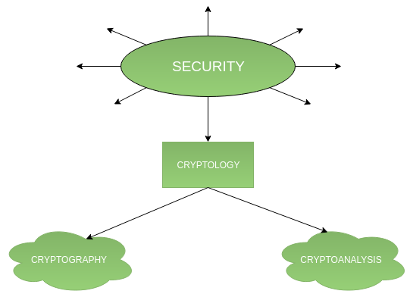

Cryptography –
Cryptography is classified into symmetric cryptography, asymmetric cryptography and hashing. Below are the description of these types.

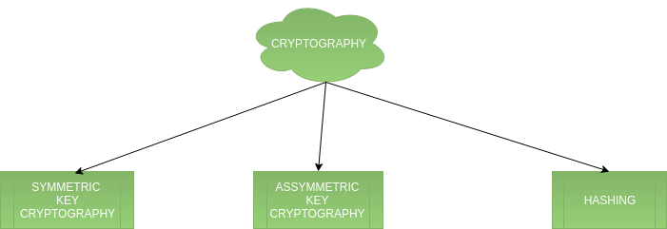

1.Symmetric key cryptography –
It involves usage of one secret key along with encryption and decryption algorithms which help in securing the contents of the message. The strength of symmetric key cryptography depends upon the number of key bits. It is relatively faster than asymmetric key cryptography. There arises a key distribution problem as the key has to be transferred from the sender to receiver through a secure channel.
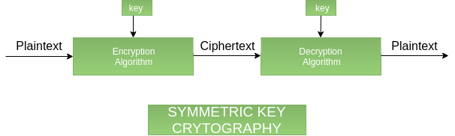

2.Assymetric key cryptography –
It is also known as public key cryptography because it involves usage of a public key along with secret key. It solves the problem of key distribution as both parties uses different keys for encryption/decryption. It is not feasible to use for decrypting bulk messages as it is very slow compared to symmetric key cryptography.

Private Key

A private key is a tiny bit of code that is paired with a public key to set off algorithms for text encryption and decryption. It is created as part of public key cryptography during asymmetric-key encryption and used to decrypt and transform a message to a readable format. Public and private keys are paired for secure communication, such as email.
A private key is also known as a secret key.

Public Key

Asymmetric is a form of Cryptosystem in which encryption and decryption are performed using different keys-Public key (known to everyone) and Private key (Secret key). This is known as Public Key Encryption.

Characteristics of Public Encryption key:
- Public key Encryption is important because it is infeasible to determine the decryption key given only the knowledge of the cryptographic algorithm and encryption key.
- Either of the two key (Public and Private key) can be used for encryption with other key used for decryption.
- Due to Public key cryptosystem, public keys can be freely shared, allowing users an easy and convenient method for encrypting content and verifying digital signatures, and private keys can be kept secret, ensuring only the owners of the private keys can decrypt content and create digital signatures.
- The most widely used public-key cryptosystem is RSA (Rivest–Shamir–Adleman). The difficulty of finding the prime factors of a composite number is the backbone of RSA.

Components of Public Key Encryption:

- Plain Text:
This is the message which is readable or understandable. This message is given to the Encryption algorithm as an input.
- Cipher Text:
The cipher text is produced as an output of Encryption algorithm. We cannot simply understand this message.
- Encryption Algorithm:
The encryption algorithm is used to convert plain text into cipher text.
- Decryption Algorithm:
It accepts the cipher text as input and the matching key (Private Key or Public key) and produces the original plain text
- Public and Private Key:
One key either Private key (Secret key) or Public Key (known to everyone) is used for encryption and other is used for decryption

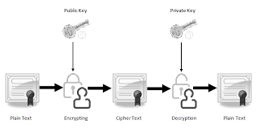

Overview of cryptography:

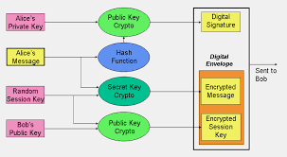

Reference:
www.geeksforgeeks.org
en.wikipedia.org
searchsecurity.techtarget.com

